Delivery Boy Job India 2026: Salary, Apply Kaise Karein aur Future Scope: Complete Guide
By Vahan · Updated: 1 June 2026 | Published: 1 June 2026
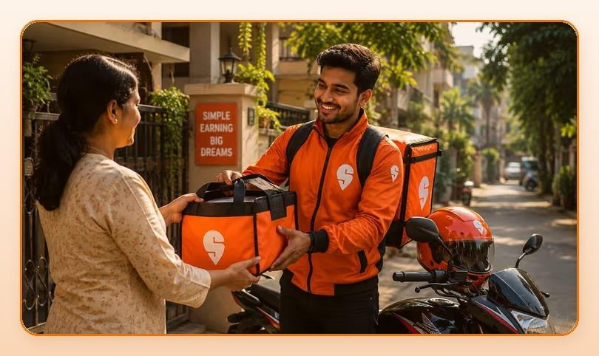
Summarize with ChatGPT · Gemini · Claude · Perplexity (tool icons in design)

Key Takeaways
- Ek dedicated delivery rider aasaani se Rs.35,000 se Rs.45,000 per month kama sakta hai, bina kisi degree ya special skill ke.
- Gig economy mein delivery jobs sabse fast-growing segment ban gayi hain, matlab job ki kami kabhi nahi hogi.
- Entry barrier almost zero hai, lekin income aur growth potential bahut high hai.
- Khud ka delivery fleet shuru karna (10-15 bikes manage karke Rs.5-10 lakh/month) bhi possible hai.

Table of Contents
- India Mein Delivery Industry Kyon Boom Kar Rahi Hai?
- Delivery Boy Salary India 2025: Platform-Wise Kitna Milta Hai?
- City-Wise Delivery Boy Salary: Apne Sheher Ka Data Dekho
- Delivery Boy Ka Daily Schedule: Kitne Ghante Kaam Karna Hota Hai?
- Delivery Job Ke Liye Kya Chahiye: Eligibility Kya Hai?
- Delivery Job Mein Career Growth: Kya Future Hai?
- Top Tips: Delivery Job Mein Zyada Kaise Kamayen?
- FAQs: Delivery Boy Job Ke Baare Mein Common Sawaal
- Conclusion: Kya Delivery Job Aapke Liye Sahi Hai?

Aaj ke time mein India mein delivery boy ka job sirf ek chhoti si naukri nahi raha. Yeh ek booming career ban gaya hai. Zomato, Swiggy, Amazon, Flipkart, Zepto, Blinkit jaise platforms ne lakho delivery partners ko stable income aur flexible kaam diya hai. COVID ke baad se is industry ne jo speed pakdi hai, woh aaj bhi barkarar hai. Agar aap ek aisi job dhundh rahe hain jo immediately income de, flexible hours offer kare, aur long-term growth bhi ho, to delivery sector ek solid choice hai.

India Mein Delivery Industry Kyon Boom Kar Rahi Hai?
India ka e-commerce aur food delivery market rocket speed se grow kar raha hai. Industry reports ke mutabiq, India ka quick commerce market 2028 tak USD 30 billion+ ho sakta hai, matlab har saal lagbhag 40-50% growth. Zomato aur Swiggy milakar 5 lakh se zyada delivery partners ko employ karte hain aur yeh number har quarter badhta ja raha hai.
Zepto, Blinkit, Dunzo aur Amazon Fresh jaise 10-minute delivery apps ke aane se riders ki maang aur tezi se badhi hai. Gig economy mein delivery jobs sabse fast-growing segment ban gayi hain, matlab job ki kami kabhi nahi hogi.

Delivery Boy Salary India 2025: Platform-Wise Kitna Milta Hai?
"Delivery boy ko kitni salary milti hai": yeh sabse common sawaal hai. Sachai yeh hai ki salary kaafi cheezoin par depend karti hai: city, platform, orders per day, aur working hours. Neeche diye gaye figures ek realistic average estimate hain:
Ek dedicated delivery rider aasaani se Rs.35,000 se Rs.45,000 per month kama sakta hai, bina kisi degree ya special skill ke. Delhi, Mumbai, Bangalore, Hyderabad jaise bade shehron mein earnings aur bhi zyada ho sakti hai. Peak hours (lunch time aur dinner time) mein double orders milte hain, aur festivals ke time special incentives bhi hote hain.
Platform / Job Type | Monthly Salary (Approx.) | Incentive / Bonus
Zomato / Swiggy Rider | Rs.25,000 - Rs.35,000 | Rs.2,000 - Rs.8,000
Amazon / Flipkart Delivery | Rs.22,000 - Rs.30,000 | Rs.1,500 - Rs.5,000
Zepto / Blinkit (Quick Commerce) | Rs.26,000 - Rs.38,000 | Rs.3,000 - Rs.10,000
Porter | Rs.23,000 - Rs.20,000 | Rs.2,000 - Rs.6,000
Self-Employed (Multiple Apps) | Rs.25,000 - Rs.45,000+ | Variable

City | Average Monthly Earnings (Incl. Incentives)
Delhi NCR | Rs.28,000 - Rs.35,000
Mumbai | Rs.30,000 - Rs.42,000
Bangalore / Hyderabad | Rs.25,000 - Rs.40,000
Pune / Chennai | Rs.18,000 - Rs.28,000
Tier-2 (Lucknow, Jaipur, Patna) | Rs.23,000 - Rs.25,000

Delivery Job Chahiye? Abhi Apply Karein.
Get Started

City-Wise Delivery Boy Salary: Apne Sheher Ka Data Dekho
Yeh figures mein surge pricing, weekend bonuses aur referral incentives shamil nahi hain. In sab ko jodne ke baad ek active delivery partner ki actual take-home income upar ki average se 20-30% zyada ho sakti hai.

Delivery Boy Ka Daily Schedule: Kitne Ghante Kaam Karna Hota Hai?
Ek full-time delivery rider generally 8-10 ghante per day kaam karta hai aur lagbhag 200-250 orders per month complete karta hai. Sabse zyada order milne ka time hota hai:
- Morning Shift: 8 AM - 2 PM
- Evening Shift: 5 PM - 11 PM
- Double Shift: 9 AM - 9 PM (maximum earning ke liye)
Agar aap sirf peak hours (12 PM-2 PM aur 7 PM-10 PM) mein active rehte hain, to ek ghante mein 3-5 deliveries easily ho jaati hain. Part-time riders bhi 4-6 ghante kaam karke acha income earn kar lete hain.

Delivery Job Ke Liye Kya Chahiye: Eligibility Kya Hai?
Bahut se logon ko lagta hai ki delivery job ke liye bahut kuch chahiye. Lekin yeh bilkul simple hai. Zaroori cheezein:
- Smartphone (koi bhi Android ya iPhone chalega)
- Two-wheeler (bike ya scooter), apni ya leased
- Two-wheeler (bike ya scooter), apni ya leased
- Valid driving license
- Aadhaar Card aur PAN Card
- Aadhaar Card aur PAN Card
- Minimum age: 18 saal
- Education: koi requirement nahi, 10th pass bhi apply kar sakte hain
Yeh job students, part-time workers, ya un logon ke liye bhi perfect hai jo apne main kaam ke saath extra income chahte hain. Kai log subah college jaate hain aur evening mein delivery karke. Rs.10,000-Rs.15,000 extra per month earn kar lete hain.

Delivery Job Mein Career Growth: Kya Future Hai?
Yeh ek common misconception hai ki delivery job mein growth nahi hoti. Sachai ekdum alag hai. Ek experienced delivery partner ke paas yeh career paths khule hain:
- Delivery Partner se Fleet Manager se City Operations Lead tak
- Khud ka delivery fleet shuru karna (10-15 bikes manage karke Rs.5-10 lakh/month)
- Logistics startup mein trainer ya team lead role
Agle 5 saalo mein India mein drone delivery, EV-based last-mile delivery aur hyperlocal commerce aur bhi tezi se grow karne wali hai. Jo aaj is sector mein enter karte hain, wo kal is growing wave ke top par honge.

Top Tips: Delivery Job Mein Zyada Kaise Kamayen?
- Peak Hours Target Karo: Lunch aur Dinner time double earning deta hai
- Multiple Apps Par Register Karo: Ek se zyada platforms se orders lena possible hai
- Customer Rating High Rakho: High rating means priority orders aur zyada income
- Incentives Track Karo: Har hafte platforms special bonuses offer karte hain
- Electric Vehicle Lo: Petrol cost zero, net earning badh jaati hai
- Route Smart Plan Karo: Short routes mein zyada deliveries matlab zyada paise

FAQs: Delivery Boy Job Ke Baare Mein Common Sawaal
Q: Delivery boy job ke liye kya kya chahiye?
Sirf ek smartphone, two-wheeler, driving license, Aadhaar aur PAN card chahiye. Koi minimum education requirement nahi hai.
Q: Zomato delivery boy ki salary kitni hoti hai?
Zomato delivery boy ki average salary Rs.25,000-Rs.35,000 per month hoti hai. Incentives aur bonuses ke saath yeh Rs.40,000+ tak pahunch sakti hai.
Q: Delivery job ke liye online apply kaise karein?
Vahan.co/jobs par jaao, apna naam aur phone number daalein, aur 2 minute mein application complete karo. Ek WhatsApp message se bhi apply hota hai!
Q: Kya part-time delivery job kar sakte hain?
Haan! Zyada platforms par aap apna schedule khud choose kar sakte hain. Part-time mein bhi Rs.10,000-Rs.15,000 per month asaani se earn ho jaata hai.
Q: Kaun sa platform sabse zyada salary deta hai?
Zepto aur Blinkit quick commerce platforms abhi sabse zyada pay kar rahe hain. Rs.28,000 se Rs.38,000 per month base salary, plus Rs.3,000-Rs.10,000 incentives.

Conclusion: Kya Delivery Job Aapke Liye Sahi Hai?
Agar aap ek aisi job dhundh rahe hain jo immediately start ho sake, achhi earning de, aur future mein grow karne ka mauka bhi de, to delivery job India mein abhi sabse better options mein se ek hai. Entry barrier almost zero hai, lekin income aur growth potential bahut high hai.
India ka delivery ecosystem ab sirf food tak limited nahi. Groceries, medicines, electronics, har cheez ghar tak pahunchti hai. Aur yeh sab possible hai delivery partners ki wajah se. Is growing revolution ka hissabano. Aaj hi apply karo!
Ab Intezaar Mat Karo! Aaj Hi Apply Karo: click here

Delivery Job Chahiye? Abhi Apply Karein: vahan.co/jobs

